### Pràctica UF4P1 - CRUD a MongoDB

#### Tasca 1



#### Tasca 2

var people1 = {name : “Luke Skywalker”,height : 172,mass : 77,hair_color : “blond”, skin_color : [‘fair’],eye_color : “blue”,birth_year: “19BBY”,gender : “male”,species : {name : “Human”,classification : “mammal”,language : “Galactic Basic”},url : “http://swapi.dev/api/people/1/”}

var people2 = {name: “C-3PO”,height: 167,mass : 75,hair_color : null,skin_color : [‘gold’],eye_color : “yellow”,birth_year : “112BBY”,gender : null,species : {name : “Droid”,classification : “artificial”,language : null},url : http://swapi.dev/api/people/2/}

var people3 = {name : “Darth Vader”,height : 202,mass : 136,hair_color : null,skin_color : [‘white’],eye_color : “yellow”,birth_year : “41.9BBY”,gender : “male”,species :{name :Human”,classification : “mammal”,language : “Galactic Basic”},url :”http://swapi.dev/api/people/4/”}

var people4 = {name: “Leia Organa”, height: 150,mass : 49,hair_color : “brown”,skin_color : [‘light’], eye_color : “brown”,birth_year : “19BBY”,gender : “female”,species :{name : “Human”,classification : “mammal”,language : “Galactic Basic”},url :”http://swapi.dev/api/people/5/”}

var people5 = {name: “Boba Fett”,height: 183,mass : 78.2,hair_color : “black”,skin_color : [‘fair’],eye_color : “brown”,birth_year : “31.5BBY”,gender : “male”,species :{name : “Human”,classification : “mammal”,language : “Galactic Basic”},url :”http://swapi.dev/api/people/22/”}

var people6 = {name: “Lama Su”,height: 229,mass : 88,hair_color : null,skin_color : [‘grey’],eye_color : “black”,birth_year : null,gender : “male”,species : {name : “Kaminoan”,classification : “amphibian”,language : “Kaminoan”},url :”http://swapi.dev/api/people/72/”}

var people7 = {name: “Finis Valorum”,height: 170,mass : null,hair_color : “blond”,skin_color : [‘fair’],eye_color : “blue”,birth_year : “91BBY”,gender : “male”,species : {name : “Human”,classification : “mammal”,language : “Galactic Basic”},url : “http://swapi.dev/api/people/34/”}

var people8 = {name: “R2-D2”,height: 96,mass : 32,hair_color : null,skin_color : [‘white blue’],eye_color : null,birth_year : “33BBY”,gender : null,species : {name : “Droid”,classification : “artificial”,language : null},url : “http://swapi.dev/api/people/3/”}

var people9 = {name: “Palpatine”,height: 170,mass : 75,hair_color : “grey”,skin_color : [‘pale’],eye_color : “yellow”,birth_year : “82BBY”,gender : “male”,species : {name : “Human”,classification : “mammal”,language : “Galactic Basic”},url : “http://swapi.dev/api/people/21/”}

var people10 = {name: “Taun We”,height: 213,mass : null,hair_color : null,skin_color : [‘grey’],eye_color : “black”,birth_year : null,gender : “female”,species : {name : “Kaminoan”,classification : “amphibian”,language : “Kaminoan”},url : “http://swapi.dev/api/people/73/”}

db.people.insertMany([people1,people2,people3,people4,people5,people6,people7,people8,people9,people10])

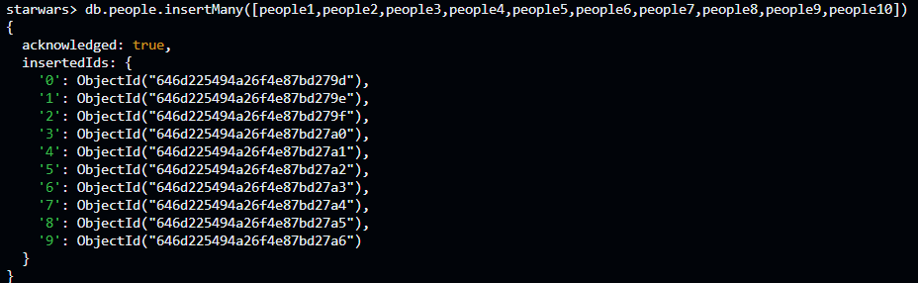

#### Tasca 3

Para insertar los documentos de film y planets lo hice de manera gráfica con el compass.

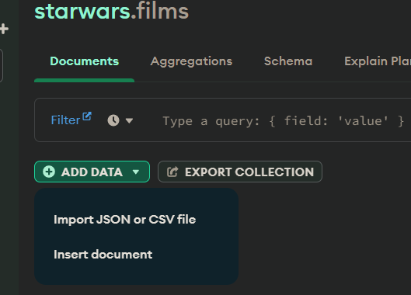

Lo hice de esta manera ya que desde el terminal no logro hacerlo:

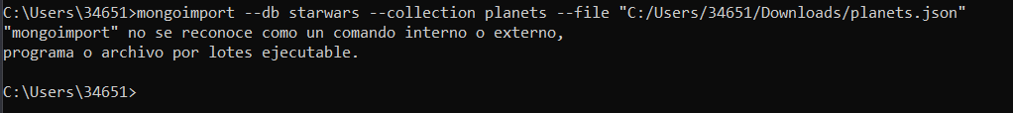

#### Tasca 4

db.people.find({“species.language”: null}, {_id: 0, name: 1, height: 1, mass: 1})

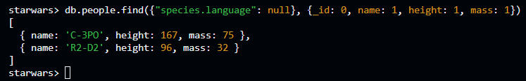

#### Tasca 5

db.people.find({$or: [{$and: [{birth_year: / "^..1/}, {gender: "male"}]},{height: {$gte: 200}}]},{_id: 0,name: 1, skin_color: 1})

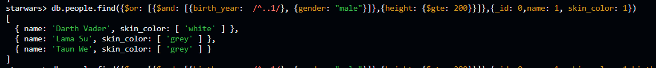

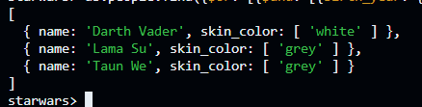

#### Tasca 6

db.films.find({director: "George Lucas",episode_id: {$lt: 4}, opening_crawl: /Republic/},{_id: 0})

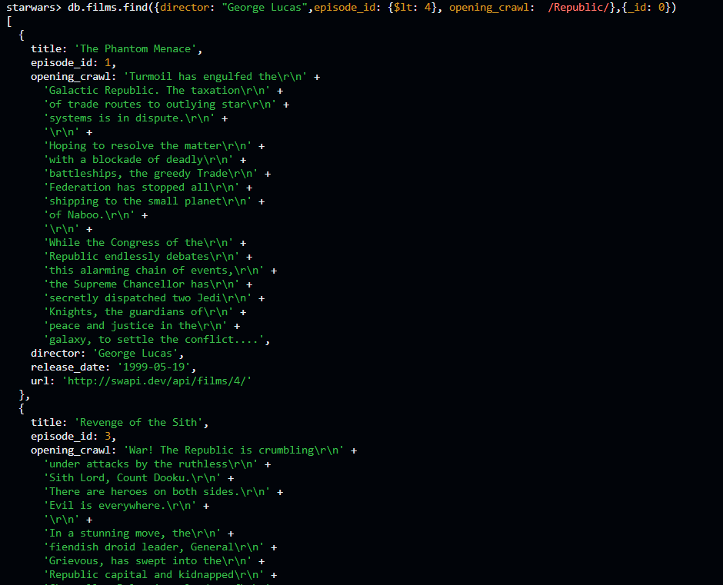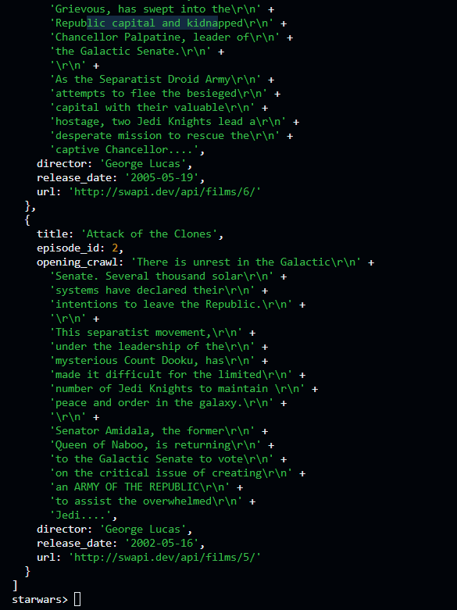

Devuelve 'The Phantom Menace', 'Revenge of the Sith' y 'Attack of the Clones'

#### Tasca 7

db.films.updateMany({title: {$in: ["A New Hope","The Empire Strikes Back"]}},{$set: {producer: ["Gary Kurtz"]}})

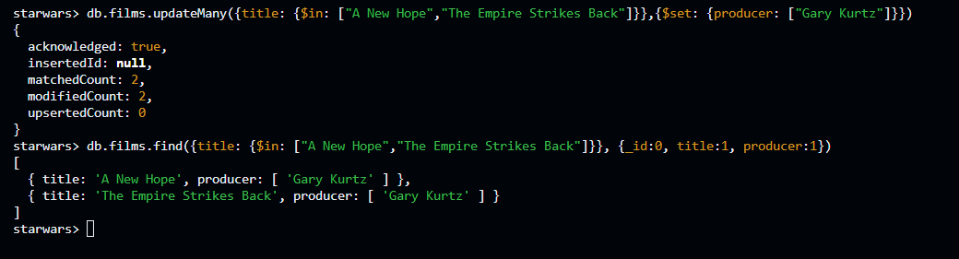

db.films.updateOne({title: "Return of the Jedi"},{$set: {producer: ["Howard G. Kazanjian","George Lucas"]}})

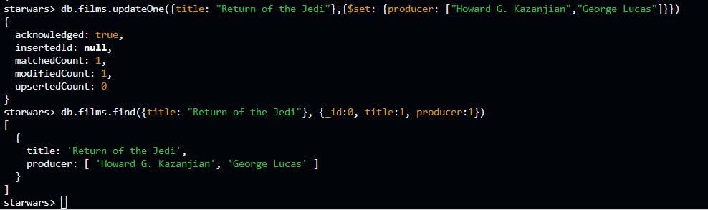

var titulos = ["The Phantom Menace", "Revenge of the Sith", "Attack of the Clones","The Empire Strickes Back", "Return of the Jedi", "A New Hope"]

db.films.updateMany({title: {$in: titulos}}, {$push: {producer: "Rick McCallum"}})

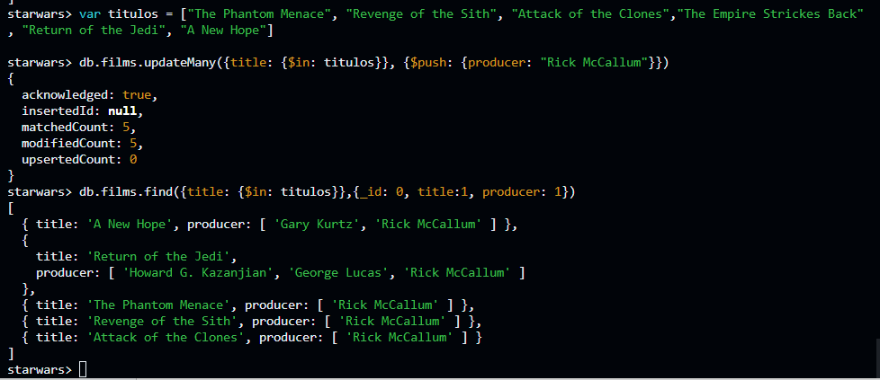

#### Tasca 8

db.planets.updateMany({surface_water: {$exists: false}},{$set:{surface_water: "N/A"}})

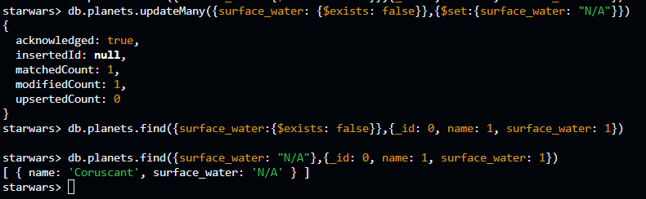

db.planets.updateMany({terrain: "mountains"},{$inc: {orbital_period: 2}})

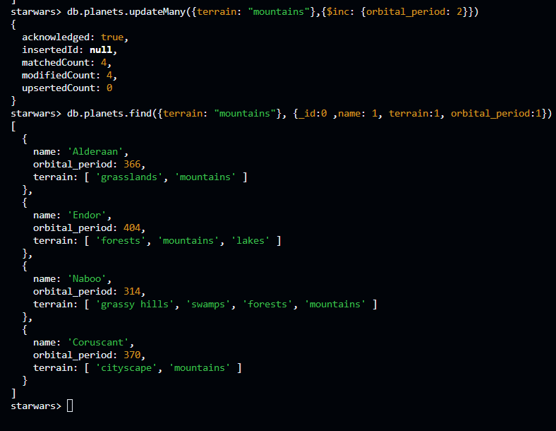

#### Tasca 9

db.planets.updateMany({gravity: "1 standard"}, {$unset: {gravity:1}}, {multi: true})

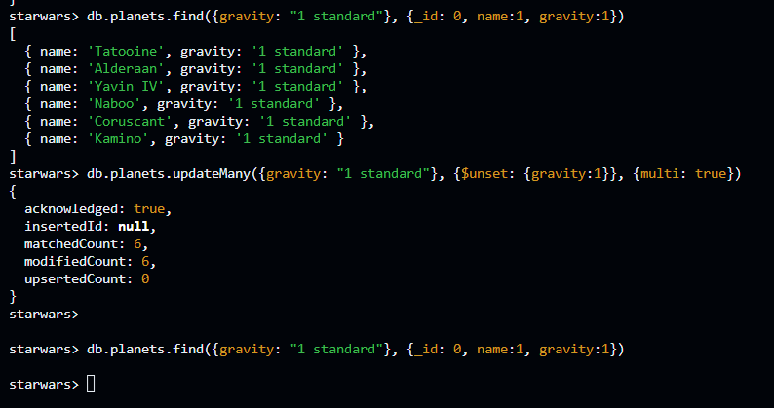

#### Tasca 10

db.people.remove({skin_color: "white"})

Aunque hay un warning y debería ser “ db.people.deleteMany({skin_color: "white"}) “.

